IT5016: Assignment #2

Software Project –

Helpdesk Ticketing System in Python

|  |  |
| --- | --- |
| **Student Name:** | **Urvashi Negi** |
| **Student ID:** | **20230854** |
| **Due Date:** | **23rd April 2023** |

**Software Development Lifecycle stages during the development of the project**

**SDLC:** Software Development Life Cycle. It is an approach to define the different phases of involved in software development. It gives the brief detail about how the project is build, deployed and maintained. It involves full cycle of the development of the software which includes- planning, creating, testing and deploying of the software.

In this program, I have created a helpdesk ticketing system, for the client and followed all the SDLC stages:

Different phases of software development life cycle are mentioned below:

1. **Planning:** In this phase we have to look in client need and requirements. Also analysing the result to provide them better potential software solution. Once all the information is analysed and concluded, it is then presented to the client before starting the software development process.

* In the planning stage, the client requirement is to create a Helpdesk Ticketing system, in this information will be collected and how much resources required for the project, how much time needed to finish the project will be identified.

1. **Requirement Analysis:** The first phase of SDLC creates project overview, project requirement and analysis. In this required information is collected from the client and create a project as per their expectations. It includes – business object model, business process model, scope document, functional requirement, non-functional requirements, compliance requirements and constraints.

* In this stage, I checked the client requirement for the helpdesk ticketing system, and created a detailed plan for it. In this I identify the data to be collected and stored and how the system user interface will be.
* The Technical requirement of the client is to create Helpdesk ticketing system and the ticket should include - Ticket number, Name of the ticket’s creator, Staff ID, Email address, Description of the issue.
* Also Develop a method Ticket class in which ticket is submitted, and the ticket should be started from 2001 (static field counter plus 2000)

1. **Design:** After preparing user requirement document, it is now time to create a high level solution which aligns with the requirements. This solution is also presented to the client and if it is approved that the development is moved to next stage. The solution design includes System Architecture and Software Architecture. Solution Design will give details of major hardware components and their function. Software Architecture will give details about system’s high level software components- framework, data structure, data components and the communication between the components. Also in Detail designing the overall system are created and designed and implemented which include coding and implementation. Detail design is done by the developer for coding the component.

* In this stage, I have checked what the hardware and software requirements of the project are. The hardware requirement is the system needed for coding and software requirement is I have used Visual Studio and written the code in python for the project.

In this I have created a menu for Helpdesk Ticketing System which is displayed like this:

* =====Helpdesk Ticketing System Program =====
* 1. Generate New ticket
* 2. Give your response to the ticket
* 3. Update and submit the ticket
* 4. See ticket stats
* 5. End the program and exit

1. **Implementation:** In this the elements of overall system are created and designed and implemented which include coding and implementation. Detail design is done by the developer for coding the component. In this the code is written, tested and debugged.

* In this stage coding is done for Helpdesk Ticketing system, which was tested and debugged.
* Coding is done in python and if there is any error it was timely debugged and implemented.

1. **Construction**: It contain unit testing of the software. The coding is created and should be align with design, framework. Libraries and database tables should be created. The code should be automated using testing tools. Once the code is automated it must be run properly every time the changes are done.

* Coding is done in which class Ticket is created, counter is set to 2000 and list of the ticket is created.
* All the tickets are saved in a list (tktlist)
* Counter is generated for assigning the ticket (assigned 2000 and will start from 2001)
* __int__ constructor is implemented to create instance of ticket details.
* Main () is created in which all the menu functioning is created and executed.
* Ticket statistics is also generated to view total generated, total resolve and to be resolved tickets.
* Inside print_menu() – main function – the menu is created and executed using if elif statement.
* And then program will end.
* When the helpdesk operator run the program, he can create, resolve, update, view ticket statistics and also can view all the tickets in detail.

1. **Testing:** Once the system is developed, it must be send to the testing team for detecting the bugs. These bugs must be fixed before delivering the completed system to the client. Three types of the testing is performed during different stages of project:

* **Unit Testing:** It focuses on individual components and check if they are individually working correctly or not. The goal is to verify the internal logic behind the component. To check if the functionality behind the component is working properly.
* **Integration Testing:** It focuses on how different components are interacting with each other in the complete project. Functionality of different part of the project is checked and tested.
* **User Acceptance Testing:** The final testing is done by client and intended audience before delivering the product to the real world. The testing is not done men-by-menu but it is verified by the client to check if the product aligns the need of end user.

The main objective of the testing is to identify the bugs as early as possible during coding phase. It is because it will be less cheap to fix the bugs during coding phase rather than when the real world experience error in the product.

* Example: Below I have created a menu in python.

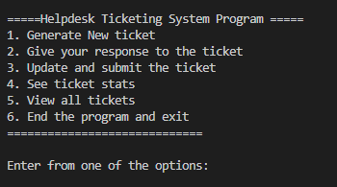

* If I will enter A, or B or any alphabet in the option. It will show invalid choice try again.

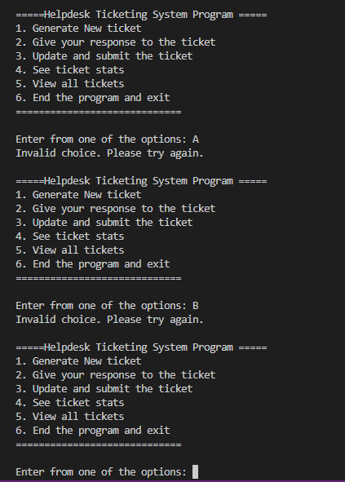

1. **Deployment:** After testing is done, the product is then deployed in the production environment. It includes installation of software, data migration, user guides, and training to users, and transition from old to new system. If the customer find the functionality clear as per the requirement then sign off is provided by the customer to go live.
2. **Operation and maintenance:** After deployment process done, developers will fix if any new bugs comes, which needed to be fix for any new enhancement needs to be done. Here we have to check if there is continuous upgrade is done if any changes in coming up.

**References**:

# Software Testing Help. (2023). SDLC (Software Development Life Cycle) Phases. <https://www.softwaretestinghelp.com/software-development-life-cycle-sdlc/>